100mm Ferrocell & Strip LED Ring Setup and Use
1. Align arrows on 4-pin connectors and push together.
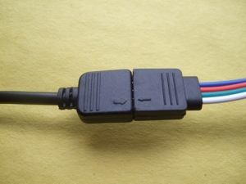
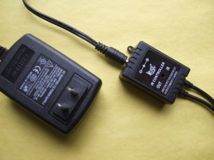
2. Connect 5mm power plug from AC adapter into jack on controller

3. Plug AC adapter into mains supply.
4. Darken the room for viewing.
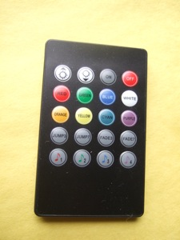
5. Press button on remote to select desired lighting (White = RGB).
6. Place light ring on flat surface with glass facing up.
7. Place magnet on top or under cell. Remove bottom cover to image top of magnet (place close to glass) NOTE: for bottom viewing you can use non-ferrous spacers under the magnet to lift it into position behind the glass.

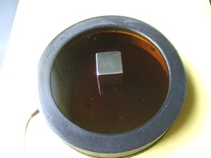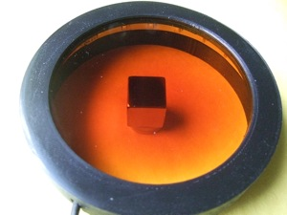

Wait 10-30 seconds for image to manifest. Move magnets position often. Resting magnet in one position for long periods of time may burn the inside surface of the glass, creating a blurred view in the affected area.

For increased contrast and detail, remove bottom cover and use a ‘black hole’:
http://ferrocell.freeforums.net/thread/33/brighter-clearer-images-using-black
Check the forum for more experiments and tips: http://ferrocell.freeforums.net/
……………………………………………………………………………………………………………………………...
> Do not place magnets of opposite polarity on both sides of Ferrocell at the same time or damage to the seal may occur.
> Clean glass surfaces with glass cleaner and lint free towel or lens paper to remove smudges or fingerprints.
> Your Ferrocell has a two (2) year replacement (or repair) warranty. You only need to pay shipping back to us if cell becomes defective.
> Any questions, please contact info@ferrocell.us for help.

